**NAME SHISHU**

**REG 2020CA089**

**WEEK-3 HTML**

* Create a webpage with HTML describing your department use paragraph and list tags.

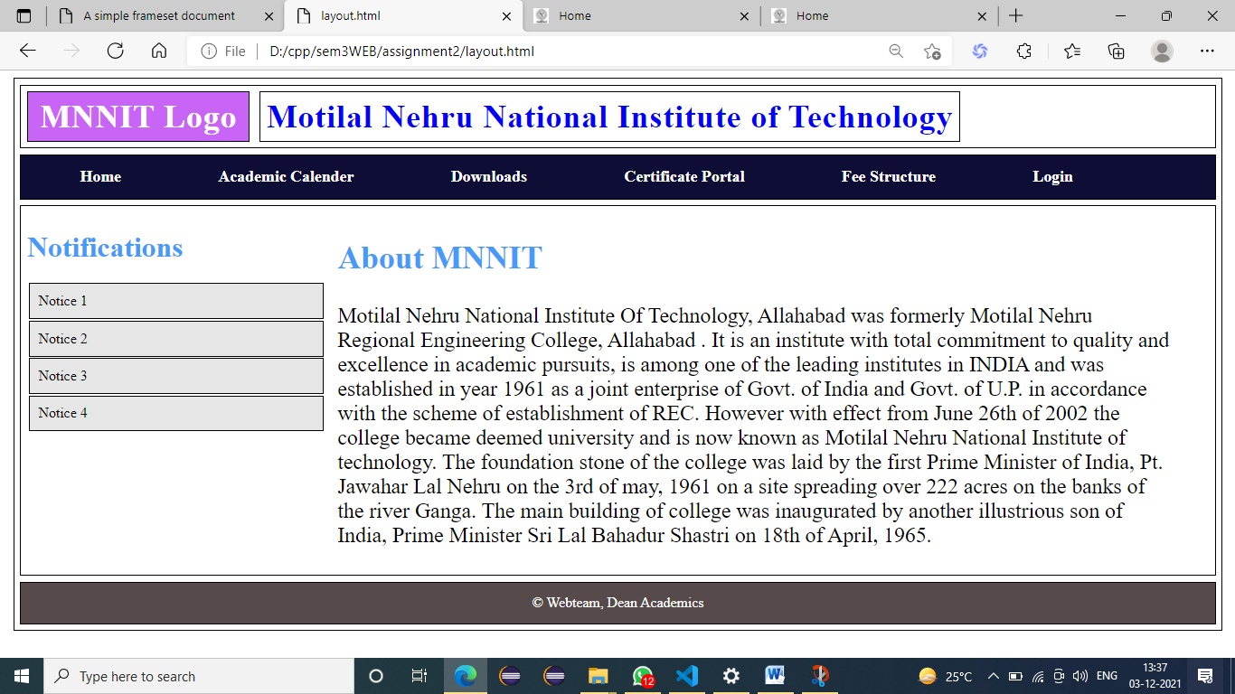

<html>

    <head>

        <link rel="stylesheet" href="style.css">

    </head>

    <body>

        <div class="body">

            <div class="header">

                <span class="logo">MNNIT Logo</span>

                <span class="name">Motilal Nehru National Institute of Technology</span>

            </div>

            <div class="nav">

                <span>Home</span>

                <span>Academic Calender</span>

                <span>Downloads</span>

                <span>Certificate Portal</span>

                <span>Fee Structure</span>

                <span>Login</span>

            </div>

            <div class="main">

                <div class="sidenav">

                    <h1 style="color:rgb(69, 154, 250); font-weight: 700;">Notifications</h1>

                    <div class="notice">Notice 1</div>

                    <div class="notice">Notice 2</div>

                    <div class="notice">Notice 3</div>

                    <div class="notice">Notice 4</div>

                </div>

                <div class="about">

                    <h2 style="color:rgb(69, 154, 250); font-weight: 700;">About MNNIT</h2>

                    <p>Motilal Nehru National Institute Of Technology, Allahabad was formerly Motilal Nehru Regional Engineering College, Allahabad . It is an institute with total commitment to quality and excellence in academic pursuits, is among one of the leading institutes in INDIA and was established in year 1961 as a joint enterprise of Govt. of India and Govt. of U.P. in accordance with the scheme of establishment of REC. However with effect from June 26th of 2002 the college became deemed university and is now known as Motilal Nehru National Institute of technology.

The foundation stone of the college was laid by the first Prime Minister of India, Pt. Jawahar Lal Nehru on the 3rd of may, 1961 on a site spreading over 222 acres on the banks of the river Ganga. The main building of college was inaugurated by another illustrious son of India, Prime Minister Sri Lal Bahadur Shastri on 18th of April, 1965.</p>

                </div>

            </div>

            <div class="footer">

                © Webteam, Dean Academics

            </div>

        </div>

    </body>

</html>

**Style.css**

div, span{

    border: 1px solid black;

    margin: 0.5%;

}

.header{

    padding: 1% 0;

}

.logo{

    padding: 0.5% 1%;

    height: 180px;

    background-color: rgb(200, 101, 246);

    font-size: 36px;

    letter-spacing: 1px;

    font-weight: 700;

    color: white;

}

.name{

    font-size: 36px;

    letter-spacing: 1px;

    font-weight: 700;

    color: blue;

    margin: 2% 2% 2% 0;

    padding: 0.5%;

}

.nav{

    padding: 1%;

    background-color: rgb(13, 13, 54);

}

.nav span{

    padding: 1% 2%;

    margin: 0.5% 2%;

    color: white;

    border: none;

    font-weight: 700;

    font-size: large;

    cursor: pointer;

}

.main{

    display: flex;

}

.sidenav{

    height: 80%;

    width: 25%;

    border: none;

}

.notice{

    padding: 3%;

    background-color: rgb(230, 230, 230);

    cursor:pointer;

}

.about{

    width: 70%;

    font-size: 24px;

    font-family: 'Times New Roman', Times, serif;

    border: None;

}

.footer{

    text-align: center;

    color: white;

    padding: 1%;

    background-color: rgb(87, 74, 74);

}

* Apply various colors to suitably distinguish key words, also apply font styling like italics, underline and two other fonts to words you find appropriate, also use header tags.

For this answer go to end of the page all thing applied below and also extra work with login form. (mam gives us to attached login form).

* Create links on the words e.g. ―Wi-Fi and ―LAN‖ to link them to Wikipedia pages.

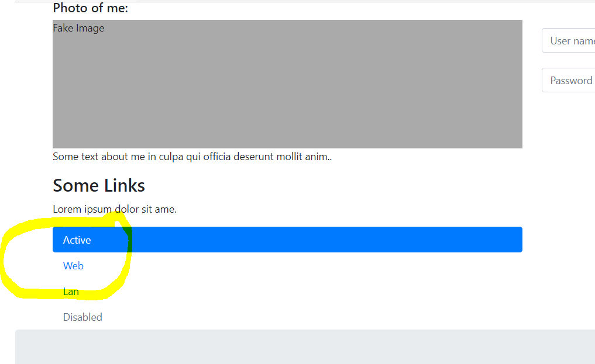

When click on web and lan then it will redirect to wikipedia

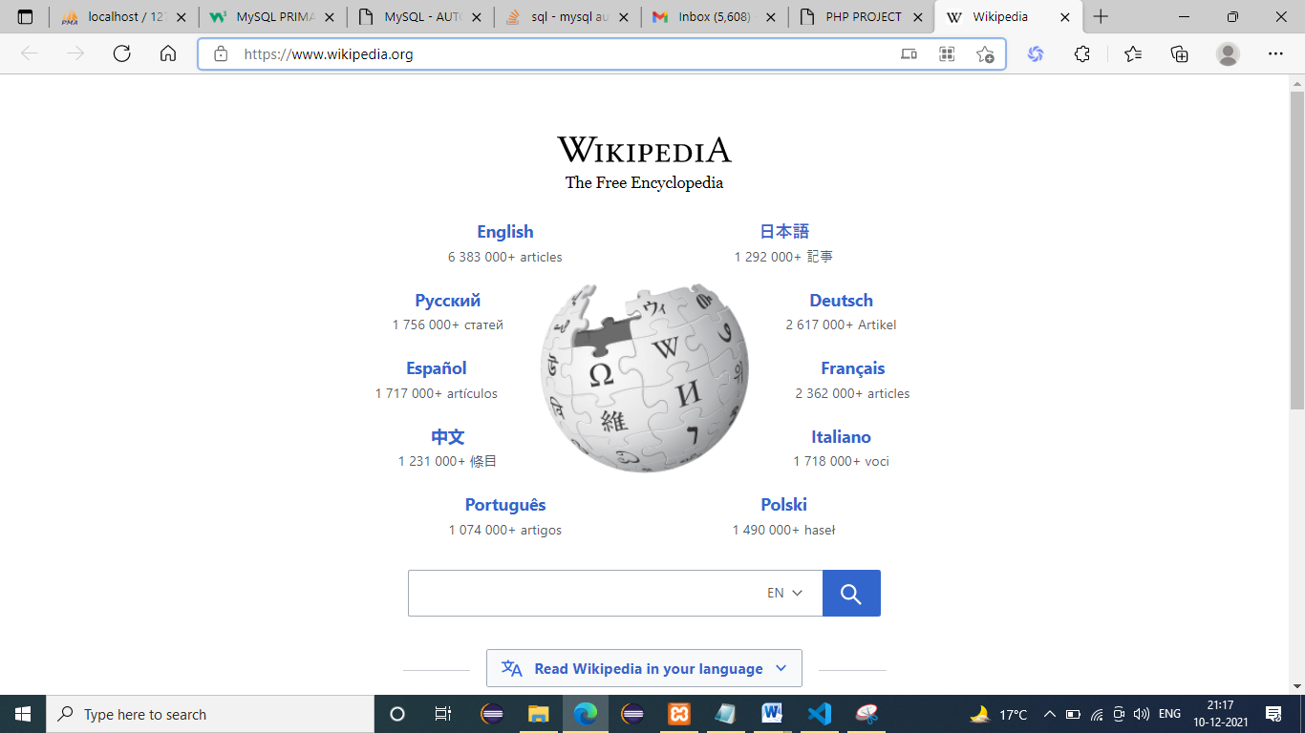

<!DOCTYPE html>

<html lang="en">

<head>

    <title>PHP PROJECT</title>

    <meta charset="utf-8">

    <meta name="viewport" content="width=device-width, initial-scale=1">

    <link rel="stylesheet" href="https://maxcdn.bootstrapcdn.com/bootstrap/4.5.2/css/bootstrap.min.css">

    <script src="https://ajax.googleapis.com/ajax/libs/jquery/3.5.1/jquery.min.js"></script>

    <script src="https://cdnjs.cloudflare.com/ajax/libs/popper.js/1.16.0/umd/popper.min.js"></script>

    <script src="https://maxcdn.bootstrapcdn.com/bootstrap/4.5.2/js/bootstrap.min.js"></script>

    <style>

        .fakeimg {

            height: 200px;

            background: #aaa;

        }

    </style>

</head>

<body>

    <div class="jumbotron text-center" style="margin-bottom:0">

        <h1>MNNIT</h1>

        <p>Resize this responsive page to see the effect!</p>

    </div>

    <nav class="navbar navbar-expand-sm bg-dark navbar-dark">

        <a class="navbar-brand" href="#">HOME</a>

        <button class="navbar-toggler" type="button" data-toggle="collapse" data-target="#collapsibleNavbar">

            <span class="navbar-toggler-icon"></span>

        </button>

        <div class="collapse navbar-collapse" id="collapsibleNavbar">

            <ul class="navbar-nav">

                <li class="nav-item">

                    <a class="nav-link" href="#">ADMIN LOGIN</a>

                </li>

                <li class="nav-item">

                    <a class="nav-link" href="#">CLIENT LOGIN</a>

                </li>

                <li class="nav-item">

                    <a class="nav-link" href="#">TECH LOGIN</a>

                </li>

            </ul>

        </div>

    </nav>

    <div class="container" style="margin-top:30px">

        <div class="row">

            <div class="col-sm-8">

                <h2>About Me</h2>

                <h5>Photo of me:</h5>

                <div class="fakeimg">Fake Image</div>

                <p>Some text about me in culpa qui officia deserunt mollit anim..</p>

                <h3>Some Links</h3>

                <p>Lorem ipsum dolor sit ame.</p>

                <ul class="nav nav-pills flex-column">

                    <li class="nav-item">

                        <a class="nav-link active" href="#">Active</a>

                    </li>

                    <li class="nav-item">

                        <a class="nav-link" target="_blank" href="https://www.wikipedia.org/">Web</a>

                    </li>

                    <li class="nav-item">

                        <a class="nav-link" target="_blank" href="https://www.wikipedia.org/">Lan</a>

                    </li>

                    <li class="nav-item">

                        <a class="nav-link disabled" href="#">Disabled</a>

                    </li>

                </ul>

                <hr class="d-sm-none">

            </div>

            <div class="col-sm-4">

                <h2><!--any thing written here--></h2>

                <h5><!--any thing written here--></h5>

                <div class="">

                    <form id="registeredUser" role="form" style="text-align: center;" class="form-horizontal" action="#" method="post"><span class="group-btn"> <!-- <a href="#" class="btn btn-danger btn-md">New User Credential </a>  -->

                        <input type="button" class="btn btn-danger btn-md" onclick="" value="Registration"></span>

                                        <h4 style="text-align: center;">Login Here</h4>

                        <div class="form-group">

                            <p>

                                <font color="red"></font>

                            </p>

                        </div>

                        <input id="loginId" name="loginId" placeholder="User name" class="form-control input-sm chat-input margin-btm" type="text" value="" /><br/>

                        <input id="password" name="password" placeholder="Password" type="password" class="form-control input-sm chat-input margin-btm" value="" />

                        <br/>

                        <div align="center">

                            <!--

                                <span class="group-btn"> <a href="#"

                                    class="btn btn-danger btn-md" id="User">Login <i

                                        class="fa fa-sign-in"></i></a>

                                </span> -->

                            <button id="User" class="btn btn-danger btn-md">

                            Login<i class="fa fa-sign-in"></i>

                            </button>

                            <span class="group-btn"> <a href="" class="btn btn-danger btn-md">TECH Login<i class="fa fa-sign-in"></i> </a></span>

                                <br><br>

                                 <span class="group-btn"> <a id="hrefId" href="#" class="btn btn-danger btn-md">ADMIN Login<i class="fa fa-sign-in"></i> </a></span><br><br>

                                <span class="group-btn"> <a href="#" class="btn btn-danger btn-md">Create ADMIN User</a></span>

                            <p>

                                <a href="#" title="Click here">Forgot Password ?</a>

                            </p>

                        </div>

                    </form><!-- aa -->

                </div>

            </div>

        </div>

    </div>

    <div class="jumbotron text-center" style="margin-bottom:0">

        <p>Footer</p>

    </div>

</body>

</html>

* Insert an image and create a link such that clicking on image takes user to other page.
* 
* Ques4.html
* <!DOCTYPE html>
* <html lang="en">
* <head>
* <meta charset="UTF-8">
* <meta name="viewport" content="width=device-width, initial-scale=1.0">
* <link href="https://fonts.googleapis.com/css2?family=Lato:wght@100;300;400&display=swap" rel="stylesheet">
* <link rel="stylesheet" href="./main.css" type="text/css">
* <title>Image experiment</title>
* </head>
* <body>
* <div id="content">
* <h2>Click the image below to go to MNNIT</h2>
* <div id="link">
* <a href="http://www.mnnit.ac.in/" target="_blank">
* <img src="./img/mnnit.jpg" alt="Google Logo"/>
* </a>
* </div>
* <button id="top" onclick="goToTop()">Go to Top</button>
* </div>
* <script>
* function goToTop() {
* document.body.scrollTop = 0;
* document.documentElement.scrollTop = 0;
* }
* </script>
* </body>
* </html>
* Ques4.css
* * {
* margin : 0;
* padding: 0;
* text-rendering: optimizeLegibility;
* font-family: 'Lato', Arial, Helvetica, sans-serif;
* color: #fff;
* }
* body {
* height: 120vh;
* background-color: #2c2c2c;
* }
* #content, a {
* height: 100%;
* display: flex;
* flex-direction: column;
* justify-content: space-around;
* align-items: center;
* }
* img {
* width: 50%;
* }
* button {
* background: #1f6bb3;
* border: none;
* padding: 10px 10px;
* cursor: pointer;
* border-radius: 20px;
* font-size: 15px;
* }
* Change the background color of the page; At the bottom create a link to take user to the top of the page.
* <a name="top"></a>
* This code written on top of the page



When we g click to link then we go to top of the page

 <a name="top"></a>

This code written on bottom of the page.

Question 2 answer

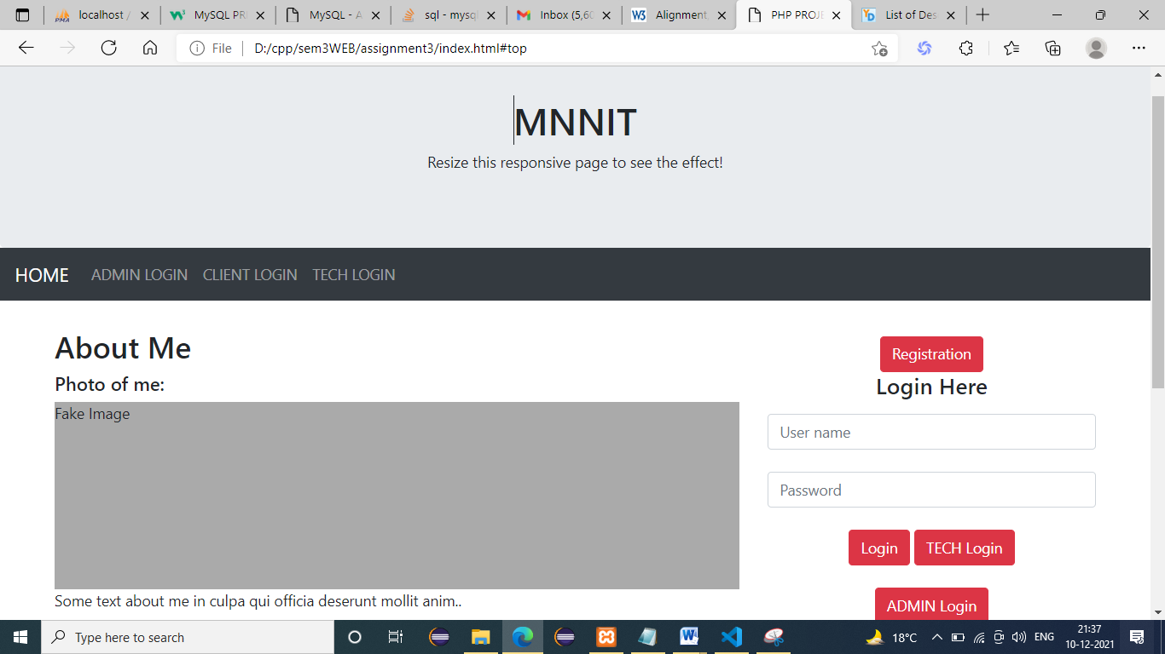

<!DOCTYPE html>

<html lang="en">

<head>

    <title>PHP PROJECT</title>

    <meta charset="utf-8">

    <meta name="viewport" content="width=device-width, initial-scale=1">

    <link rel="stylesheet" href="https://maxcdn.bootstrapcdn.com/bootstrap/4.5.2/css/bootstrap.min.css">

    <script src="https://ajax.googleapis.com/ajax/libs/jquery/3.5.1/jquery.min.js"></script>

    <script src="https://cdnjs.cloudflare.com/ajax/libs/popper.js/1.16.0/umd/popper.min.js"></script>

    <script src="https://maxcdn.bootstrapcdn.com/bootstrap/4.5.2/js/bootstrap.min.js"></script>

    <style>

        .fakeimg {

            height: 200px;

            background: #aaa;

        }

    </style>

</head>

<body>

    <a name="top"></a>

    <div class="jumbotron text-center" style="margin-bottom:0">

        <h1>MNNIT</h1>

        <p>Resize this responsive page to see the effect!</p>

    </div>

    <nav class="navbar navbar-expand-sm bg-dark navbar-dark">

        <a class="navbar-brand" href="#">HOME</a>

        <button class="navbar-toggler" type="button" data-toggle="collapse" data-target="#collapsibleNavbar">

            <span class="navbar-toggler-icon"></span>

        </button>

        <div class="collapse navbar-collapse" id="collapsibleNavbar">

            <ul class="navbar-nav">

                <li class="nav-item">

                    <a class="nav-link" href="#">ADMIN LOGIN</a>

                </li>

                <li class="nav-item">

                    <a class="nav-link" href="#">CLIENT LOGIN</a>

                </li>

                <li class="nav-item">

                    <a class="nav-link" href="#">TECH LOGIN</a>

                </li>

            </ul>

        </div>

    </nav>

    <div class="container" style="margin-top:30px">

        <div class="row">

            <div class="col-sm-8">

                <h2>About Me</h2>

                <h5>Photo of me:</h5>

                <div class="fakeimg">Fake Image</div>

                <p>Some text about me in culpa qui officia deserunt mollit anim..</p>

                <h3>Some Links</h3>

                <p>Lorem ipsum dolor sit ame.</p>

                <ul class="nav nav-pills flex-column">

                    <li class="nav-item">

                        <a class="nav-link active" href="#">Active</a>

                    </li>

                    <li class="nav-item">

                        <a class="nav-link" target="_blank" href="https://www.wikipedia.org/">Web</a>

                    </li>

                    <li class="nav-item">

                        <a class="nav-link" target="_blank" href="https://www.wikipedia.org/">Lan</a>

                    </li>

                    <li class="nav-item">

                        <a class="nav-link disabled" href="#">Disabled</a>

                    </li>

                </ul>

                <hr class="d-sm-none">

            </div>

            <div class="col-sm-4">

                <h2><!--any thing written here--></h2>

                <h5><!--any thing written here--></h5>

                <div class="">

                    <form id="registeredUser" role="form" style="text-align: center;" class="form-horizontal" action="#" method="post"><span class="group-btn"> <!-- <a href="#" class="btn btn-danger btn-md">New User Credential </a>  -->

                        <input type="button" class="btn btn-danger btn-md" onclick="" value="Registration"></span>

                                        <h4 style="text-align: center;">Login Here</h4>

                        <div class="form-group">

                            <p>

                                <font color="red"></font>

                            </p>

                        </div>

                        <input id="loginId" name="loginId" placeholder="User name" class="form-control input-sm chat-input margin-btm" type="text" value="" /><br/>

                        <input id="password" name="password" placeholder="Password" type="password" class="form-control input-sm chat-input margin-btm" value="" />

                        <br/>

                        <div align="center">

                            <!--

                                <span class="group-btn"> <a href="#"

                                    class="btn btn-danger btn-md" id="User">Login <i

                                        class="fa fa-sign-in"></i></a>

                                </span> -->

                            <button id="User" class="btn btn-danger btn-md">

                            Login<i class="fa fa-sign-in"></i>

                            </button>

                            <span class="group-btn"> <a href="" class="btn btn-danger btn-md">TECH Login<i class="fa fa-sign-in"></i> </a></span>

                                <br><br>

                                 <span class="group-btn"> <a id="hrefId" href="#" class="btn btn-danger btn-md">ADMIN Login<i class="fa fa-sign-in"></i> </a></span><br><br>

                                <span class="group-btn"> <a href="#" class="btn btn-danger btn-md">Create ADMIN User</a></span>

                            <p>

                                <a href="#" title="Click here">Forgot Password ?</a>

                            </p>

                        </div>

                    </form><!-- aa -->

                </div>

            </div>

        </div>

    </div>

    <div class="jumbotron text-center" style="margin-bottom:0">

        <a href="#top">LINK TO GO TOP OF THE PAGE</a>

        <p>Footer</p>

    </div>

</body>

</html>